DM Classic datoer 2025:
DM 1. 17-05 Hedeland
DM 2. 21-06 Randers
DM 3. 23-08 Næstved
DM 4. 06-09 Nord Als Nordborg
DM 5. 20-09 Svendborg
Internationale race 2025:
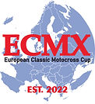 www.ecmxcup.de
Classic European Championship (CEC)
1. 10.05.2025 Stribro CZE
2. 14.06.2025 Veszpremvarsany HUN
3. 05.07.2025 Laubus Eschbach GE
4. 16.08.2025 TEAM
---------------------------------------------------------------------------
www.classicmx.se
CEMAR RACE
24 Maj Dall Danmark
07 Juni Ballenstedt Tyskland
28 Juni Norge
2-3 August Linköping Sverige
Orp Le Grande Belgium
30-31 August 2025

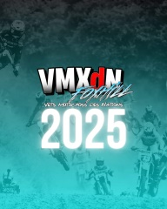
22-23-24-25 august 2025. Make sure you book out the dates. VMXDN Foxhill
Vmxdn foxhill group

🇬🇧 Farleigh Castle vmxdn
Farleigh 13-14 September 2025
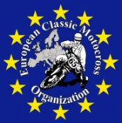
www.classicmotorsport.eu
Classic Moto Cross des Nation (CMCdN)
13-09-2025 Reading England

